Java notes

**Programming paradigms** are fundamental styles of programming, or the way a program achieves its goal.

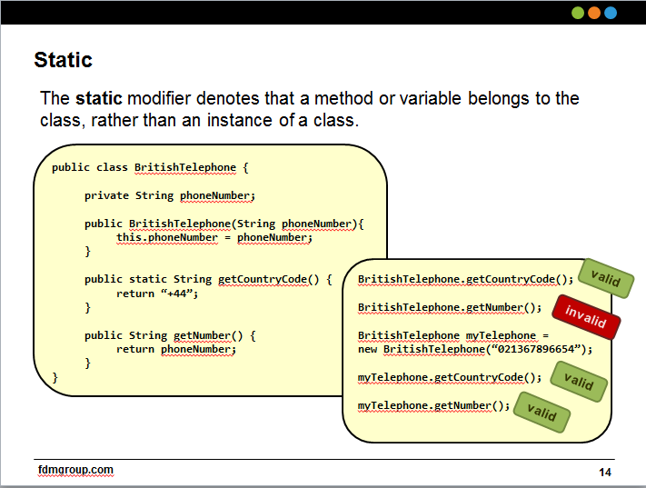

Some key paradigms are:

* + Declarative
  + Functional
  + Imperative
  + Logic
  + Object-Oriented
  + Symbolic

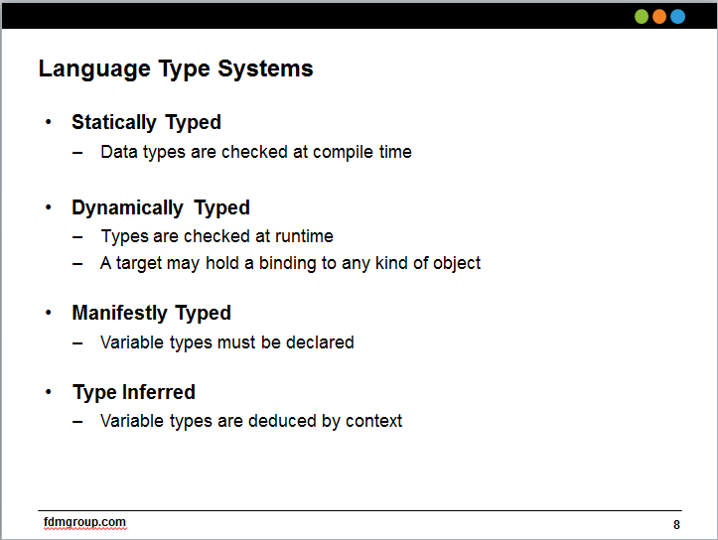

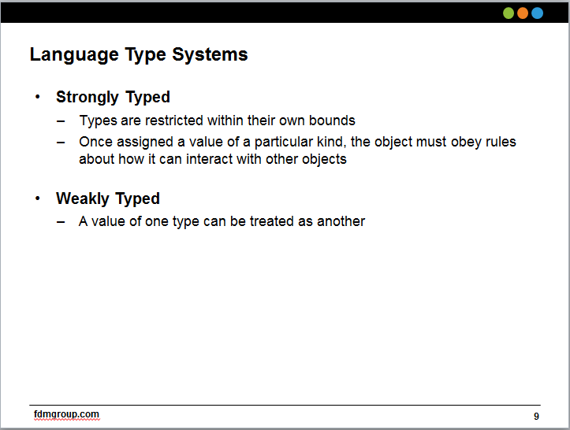

Constructors

This () – refers to a constructor in the same class. Not to be confused with java’s this

Abstract – creates a template of methods that child classes must implement. But the abstract class itself cannot implement anything if the method is “abstract”

Interfaces describes what an object can do.

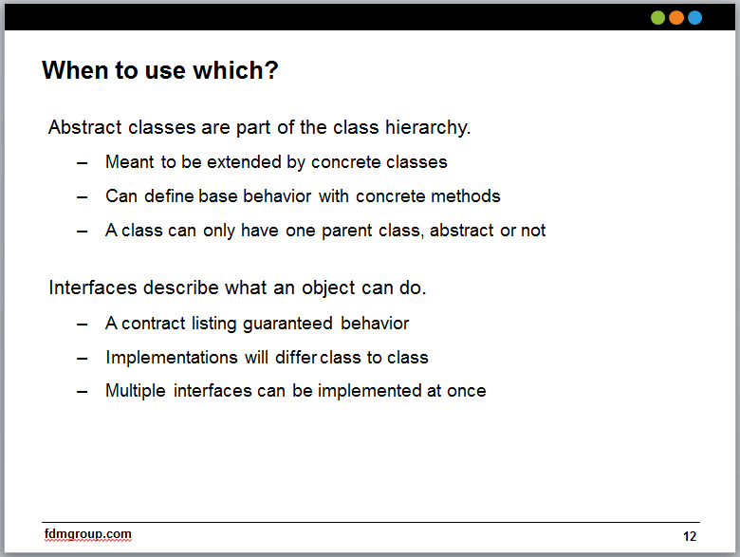

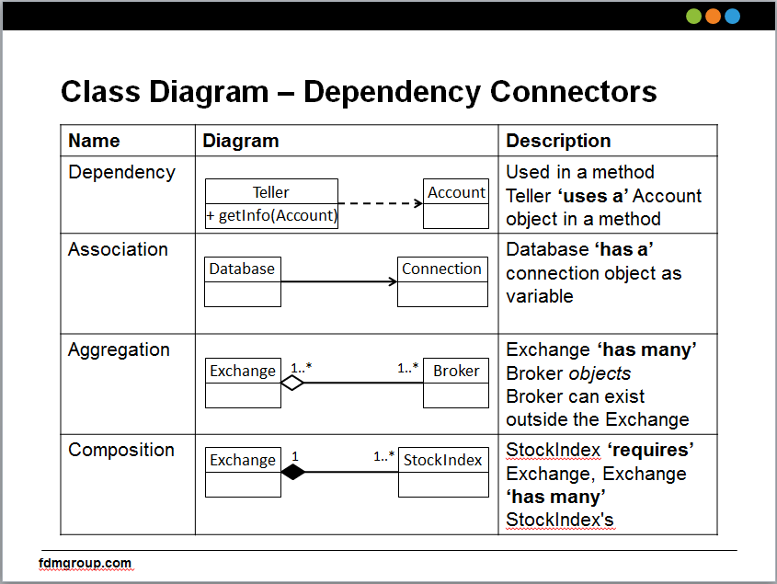

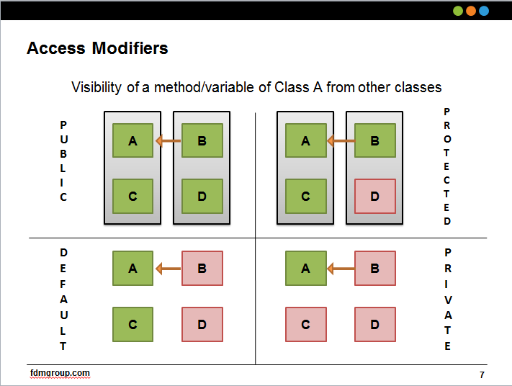

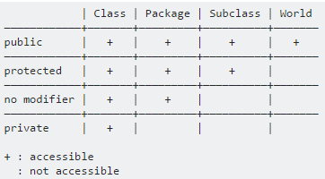

Auto-boxing & Un-boxing:

When parsing use the wrapper type (Integer I = …) versus the primitive type (int I)

Widening

varargs

Junit

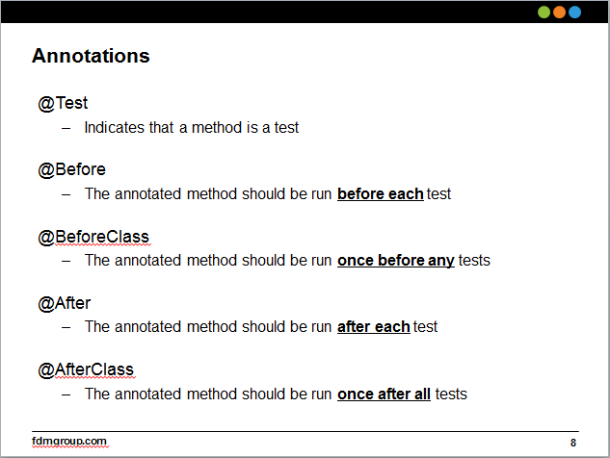

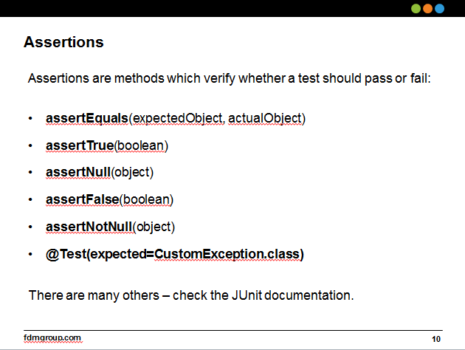

Generics

* E - Element (used extensively by the Java Collections Framework)
* K - Key
* N - Number
* T - Type
* V - Value
* S,U,V etc. - 2nd, 3rd, 4th types

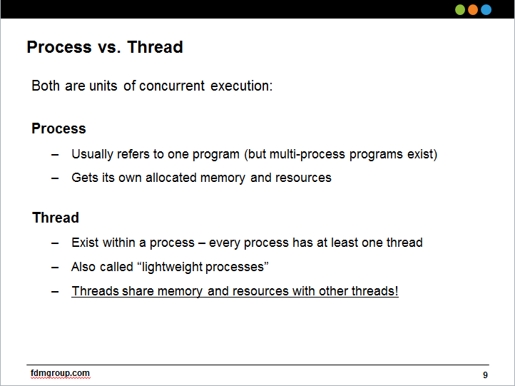

Threading

A thread is essentially a process that does not have a full stack of memory associated for it.

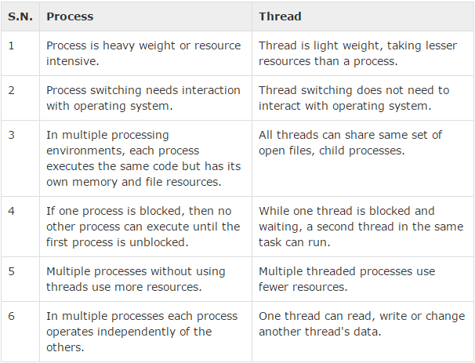

Race

Starvation

Livelock

Deadlock